Bakery Automated Mechanism (BAM)
User Manual and Documentation
Developed by: Hei Leong Leo Ng (Team Ichigan)

Context
The Bakery Automated Mechanism (BAM) is a simple program designed to help the scheduling process of the Bakery Team of Gate Gourmet Japan (GGJ). This program was created through the understanding of GGJ’s needs and integrating it with their current workflow system.
Programming language used: Python

What does it do (and how does it help)
This simple program was created to support GGJ’s bakery team in their scheduling. According to given information from Erika Nitta (Sous Chef), she must spend a very large amount of time in the monthly scheduling and hand that spreadsheet over by the 25th of each month. With so much work already on her plate, doing such a tiresome task would lead her to feel stressed, which might lead to more bias in her scheduling techniques and cause a lot of overtime work for her. This program aims to solve, or at least reduce, all these problems.

This program will stick to their current process of manual scheduling (working with excel spreadsheets) to ensure familiarity and ease of use.

Instructions

Installation
- Install python from the website and follow the instructions
https://www.python.org/downloads/

- Run “install_modules.bat” file to install all modules

Excel Spreadsheet
- Create a new template for the month that you want to schedule. (Below example is for August 2024)
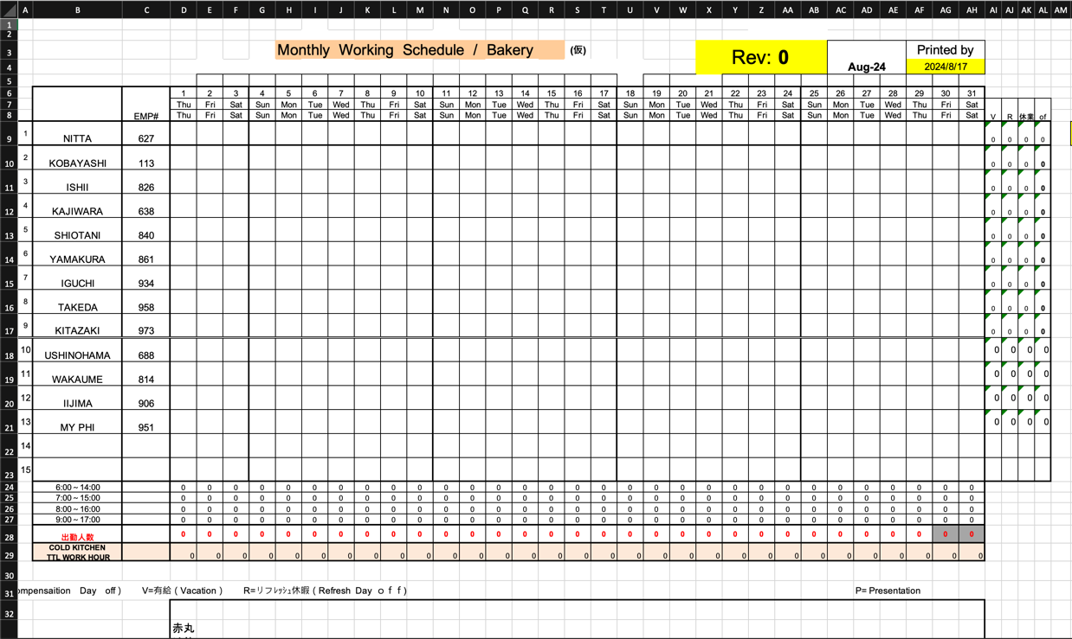
- Make sure that the template is empty (The program will not work if the spreadsheet has information in it)
- Place template inside the folder that contains the program (called inputs)

Filling in a sample schedule
- Open the program (known as Bakery Automated Mechanism.exe)
- Press “Run Script” to begin filling scheduling
- The words “Optimal Schedule Found” should appear once complete. If something other than that is outputted, please contact the developer of this program to see what errors have occurred.
- To check whether it has been filled, please re-open the spreadsheet again. (The below image is an example of how it should be filled)
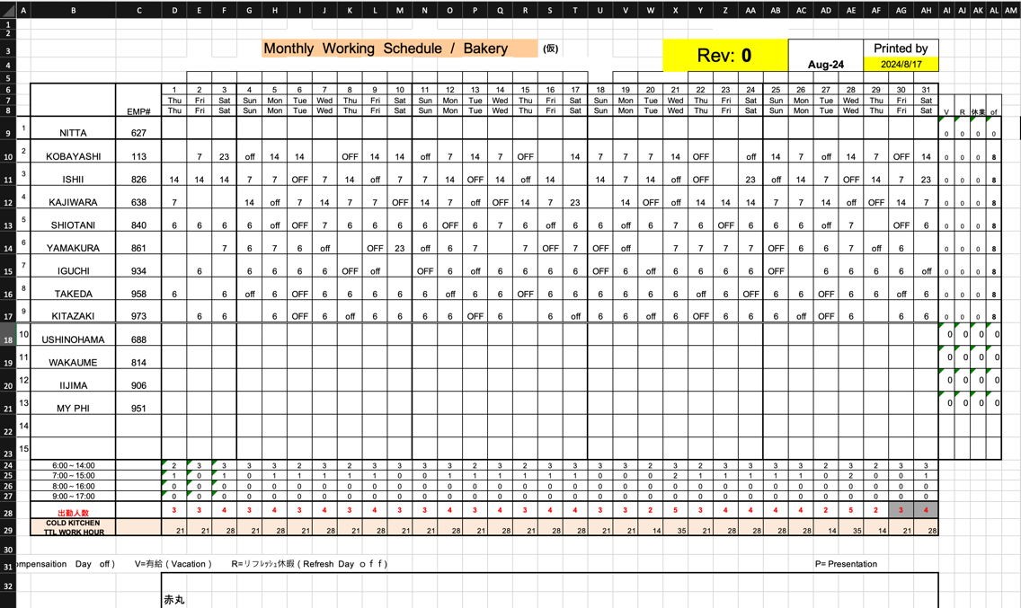

Inputting Vacations and Refresh Off Days (V, R)
- Select the day which a vacation day or a refresh day is to be inputted, using the day and month
- Press “Load Values” to show the day’s required assignments and the current scheduling information
- Press “Edit” to edit in a vacation day. When done, press “Save”
- Check if headcount is fulfilled for that day. If not, if there are more available people, check whether they are able to fill in one of the spots by checking their skills list.
- To check skills list, select a name from the dropdown and press “Load Skills”. The list of their skills will be shown.
- If a suitable person is found, press “edit” to give them the shift, and then press “save”.

Known issues of this program
- The program does not consider the normal off days (OFF) and the compensation off days (off) for the first week if the month doesn’t start on a Sunday. These days will have to be inputted manually.
- The program does not consider people who are off for vacations for a long time. If a person is removed from a month due to them being away for the whole month, the program will fail as it cannot satisfy the constraints.
- The program does not consider people who might need training. If their skill is listed in the skill matrix as “Not Supported” (NS), then they will never be put onto the spreadsheet.
- If there’s no optimal solution found, the program will not output anything into the schedule, meaning manual scheduling will have to be used again.

Improvements to the program (future)
- Incorporating the ability to preset vacations into the spreadsheet before running the program (to save time from manual editing)
Idea:
  - By removing the hardcoded headcount constraint and putting a comment on the column that doesn’t have the headcount, we can use the program to detect these comments to highlight which days have not enough people (putting those days into a dropdown menu so that all conflicts can be cleared) – This idea is currently being explored
- Clearer labels to understand why the schedule could not be created should it happen (print out which constraint has not been satisfied)
- Provide a better interface to edit the spreadsheet on the program
- Ability to incorporate people who have a Not Supported status in a skill to train them.
- Change to day-by-day scheduling for the algorithm (slower runtime), which might allow for quicker edits and understanding of the situation – similar to SchedulingAI’s in-house program for the transport team (AI Group 2)

Contact
Should you have any questions regarding the program or the different constraints, please feel free to contact the developer from the details below.

Name: Hei Leong Leo Ng
Email: leongheileong@gmail.com
Phone: +61 452 385 582

